**OUTPUT:**

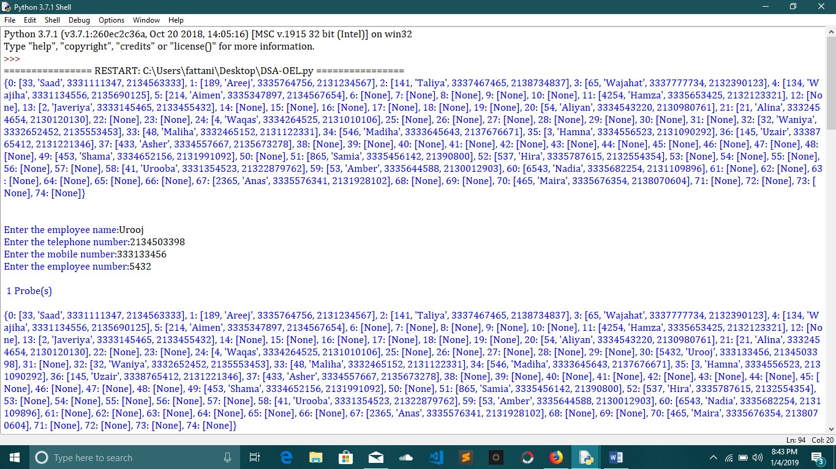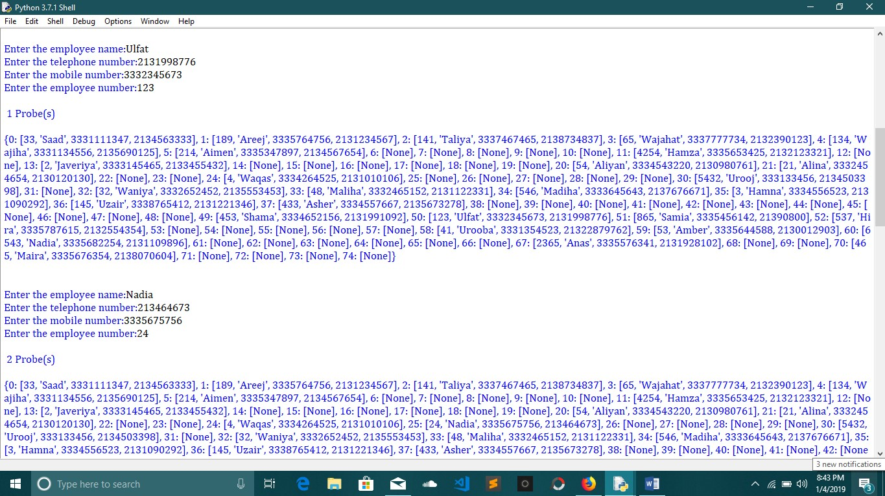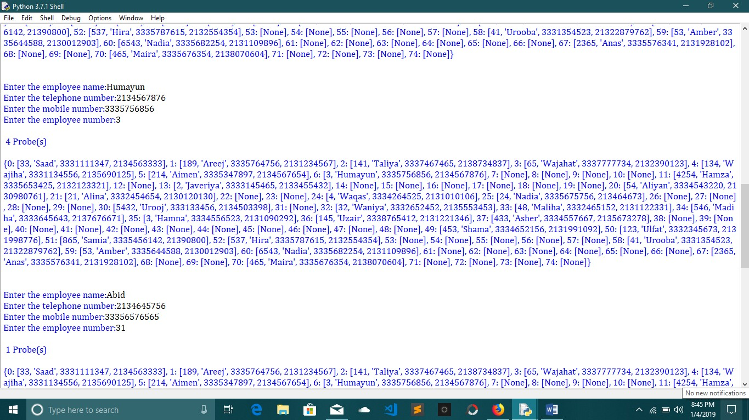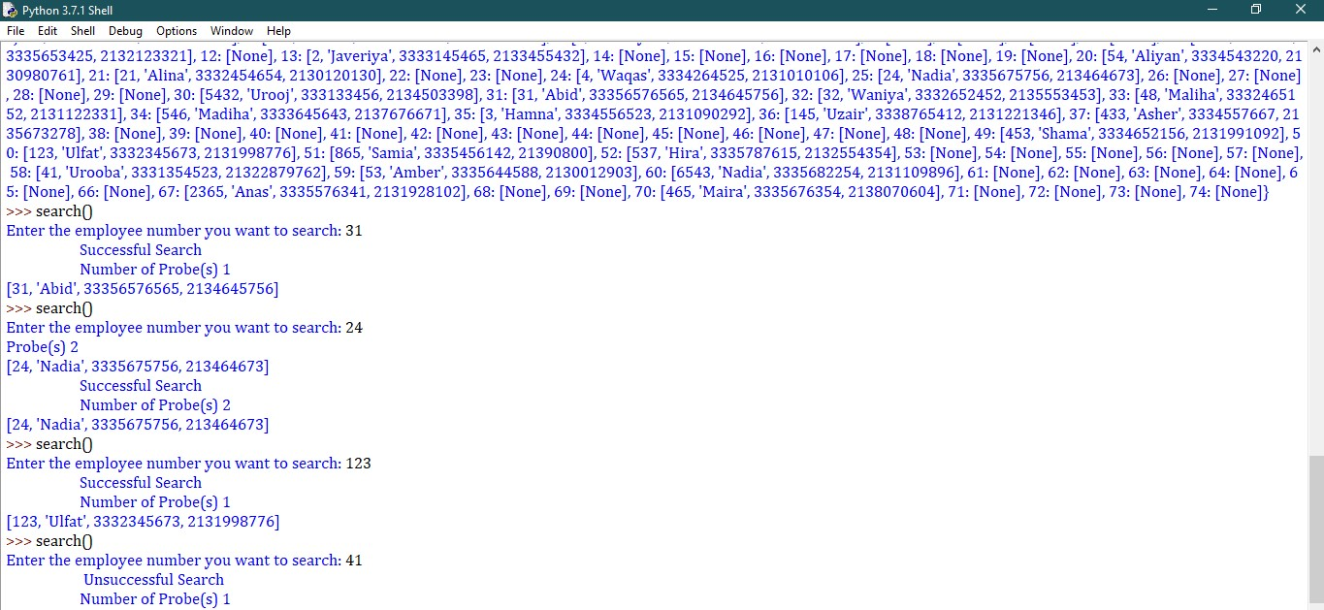

**REPORT:**

A hash function is any function that can be used to map data of arbitrary size to data of a fixed size. The values returned by a hash function are called hash values, hash codes, digests, or simply hashes.

**ALGORITHM BEHIND THE PROGRAM:**

A table consists of a dictionary named as hashtable. The length of the table is 75. It consists of a key and Value. Starting from the first ‘for’ loop, the user will give inputs for the data of employee like name, mobile, landline and employee number.

The user will give 30 inputs at a time since the loop will run 30 times. The length of the employee number should be less than six or else the loop will break. The employee number that user enters will be mod with 73 to obtain a hash value. We will initiate a counter variable. When the key of the dictionary is not empty and hashing value is 72, counter variable will increment as well as the hashing key, if it can not find the key at the first desired slot, it will linearly probe to the next slot. If the next slot is also filled it will increment to the second next slot until it does not find an empty slot, and will insert the whole employee data to the hash table. Then we will print the counter variable which will show the probing of the hashed key. That was for the insertion.

While searching, user will enter employee number to find the record, we will start with false assumption and will find for the key which is not empty. If the key of employee number matches the zeroth index of the hashed key of the main hash table, then found will become true and the loop will break. We will increment the hashing key as well as counter variable. Then we will print the counter that will show the search count and will print the desired key of the main hash table that will yield the data of the employee.

If found remains true throughout the loop, the counter will give the number of probes for successful searches.

If found remains false throughout the loop , the counter will give the number of probes for unsuccessful searches.